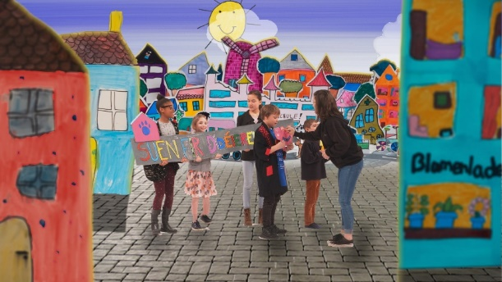
UNSERE IDEE

Gruppe:
____________________________________________

Dafür wollen wir uns einsetzen:
__________________________________________________________________________________
__________________________________________________________________________________
__________________________________________________________________________________
Weil:
__________________________________________________________________________________
__________________________________________________________________________________
__________________________________________________________________________________
So wollen wir das machen:
__________________________________________________________________________________
__________________________________________________________________________________
__________________________________________________________________________________
Mit diesen Leuten muss man sprechen:
__________________________________________________________________________________
__________________________________________________________________________________
Das machen wir als erstes:
__________________________________________________________________________________
__________________________________________________________________________________

