Zum Film
Vun der Spillplaz zum Gesetz – e Film vu Kanner fir Kanner

Von der Idee zum Gesetz – die verschiedenen Etappen des Spielplatzgesetzes
Schau Dir die Bilder an und beschreibe in ein bis zwei Sätzen, was passiert.
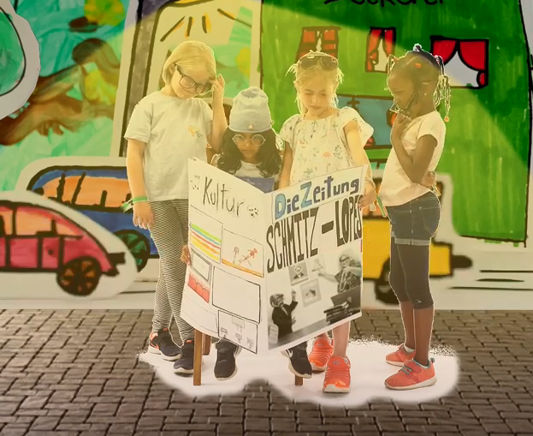 | ___________________________________  ___________________________________  ___________________________________  ___________________________________  ___________________________________  ___________________________________  ___________________________________  ___________________________________
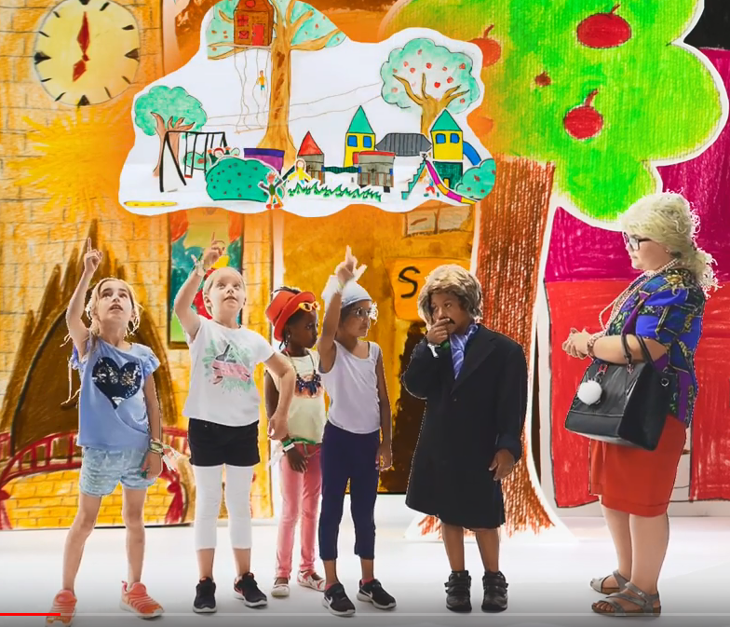 | ___________________________________  ___________________________________  ___________________________________  ___________________________________  ___________________________________  ___________________________________  ___________________________________  ___________________________________
___________________________________
___________________________________
___________________________________
___________________________________
___________________________________
___________________________________
___________________________________
___________________________________
___________________________________
___________________________________
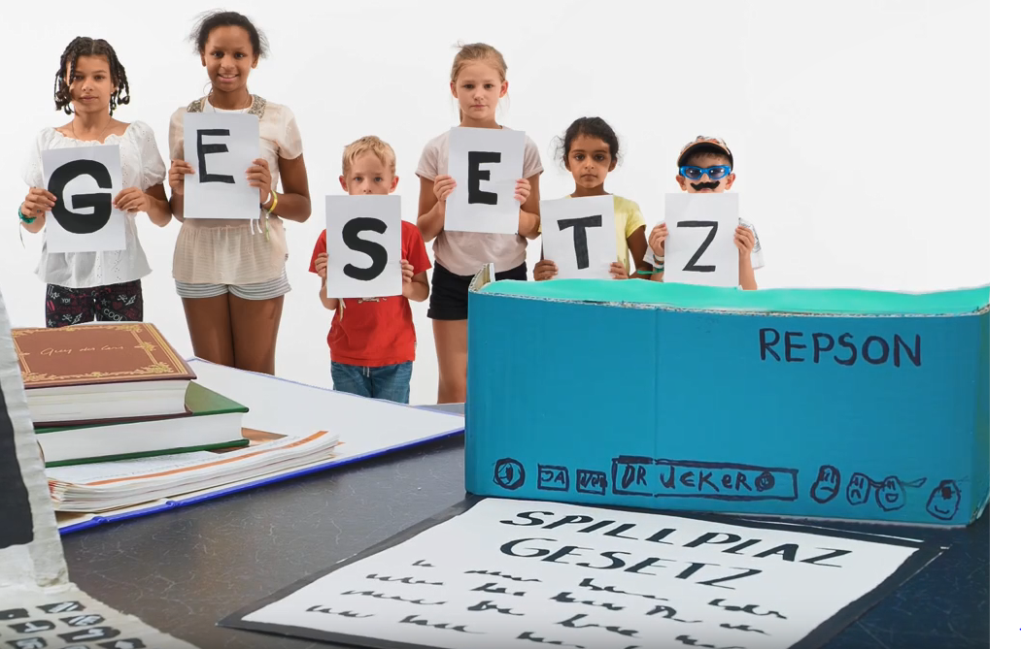 | ___________________________________  ___________________________________  ___________________________________  ___________________________________  ___________________________________  ___________________________________  ___________________________________
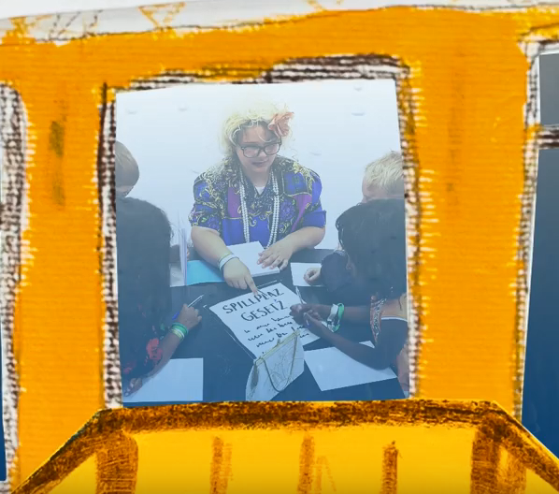 | ___________________________________  ___________________________________  ___________________________________  ___________________________________  ___________________________________  ___________________________________  ___________________________________
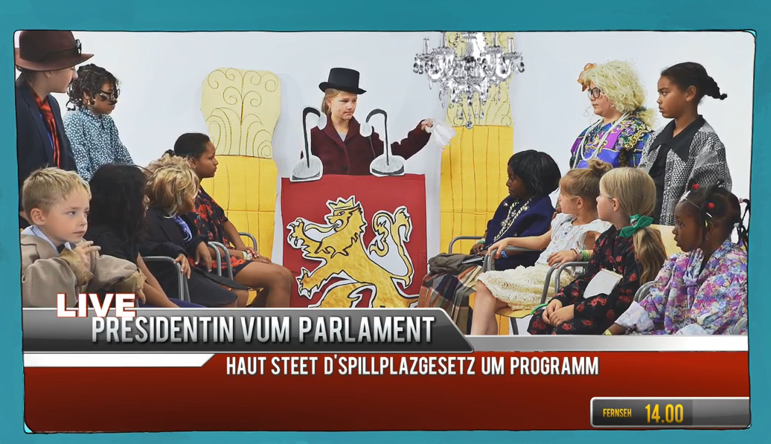 | ___________________________________  ___________________________________  ___________________________________  ___________________________________  ___________________________________  ___________________________________  ___________________________________
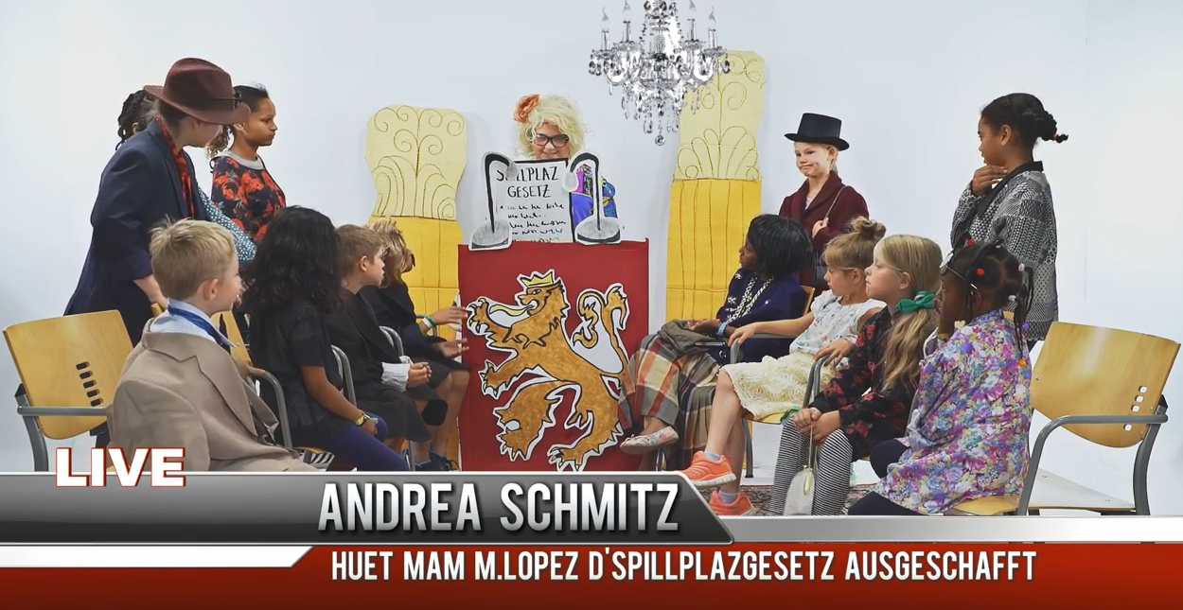 | ___________________________________  ___________________________________  ___________________________________  ___________________________________  ___________________________________  ___________________________________  ___________________________________
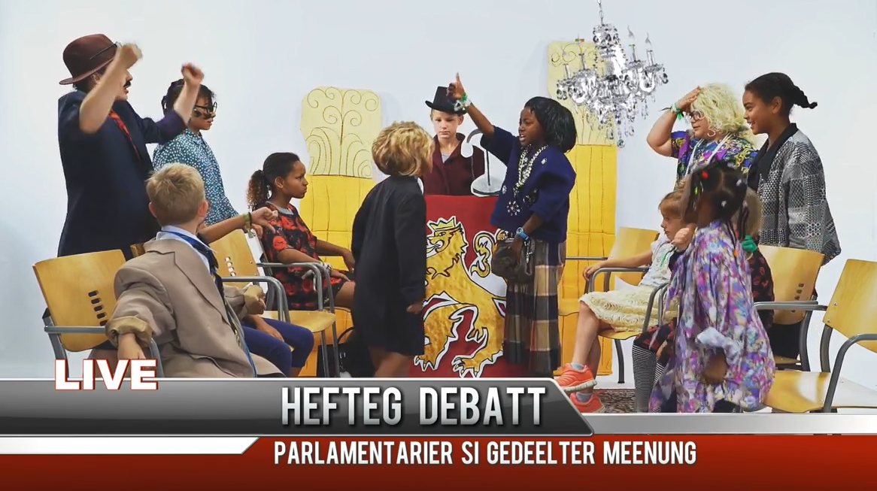 | ___________________________________  ___________________________________  ___________________________________  ___________________________________  ___________________________________  ___________________________________  ___________________________________
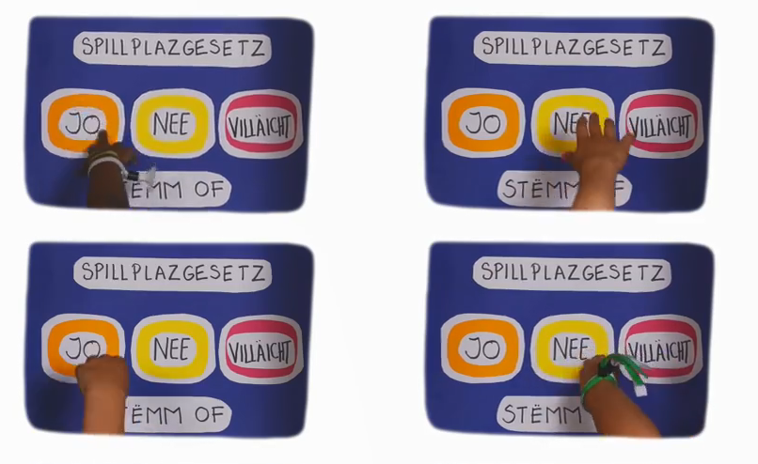 | ___________________________________  ___________________________________  ___________________________________  ___________________________________  ___________________________________  ___________________________________
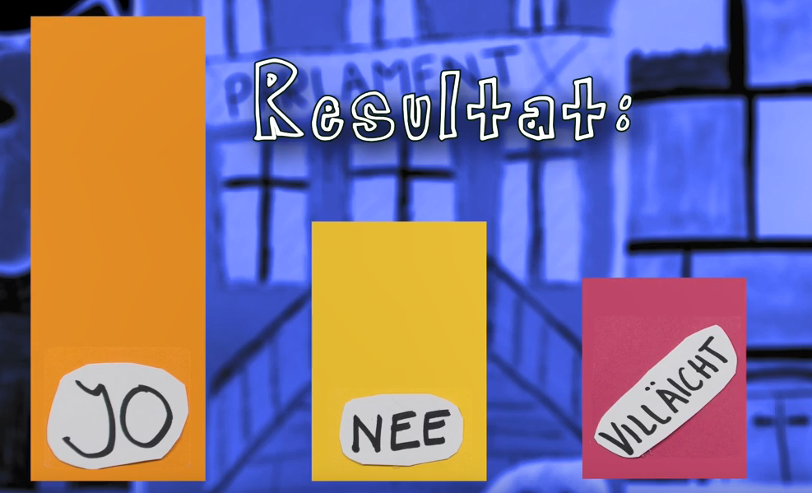 | ___________________________________  ___________________________________  ___________________________________  ___________________________________  ___________________________________  ___________________________________  ___________________________________
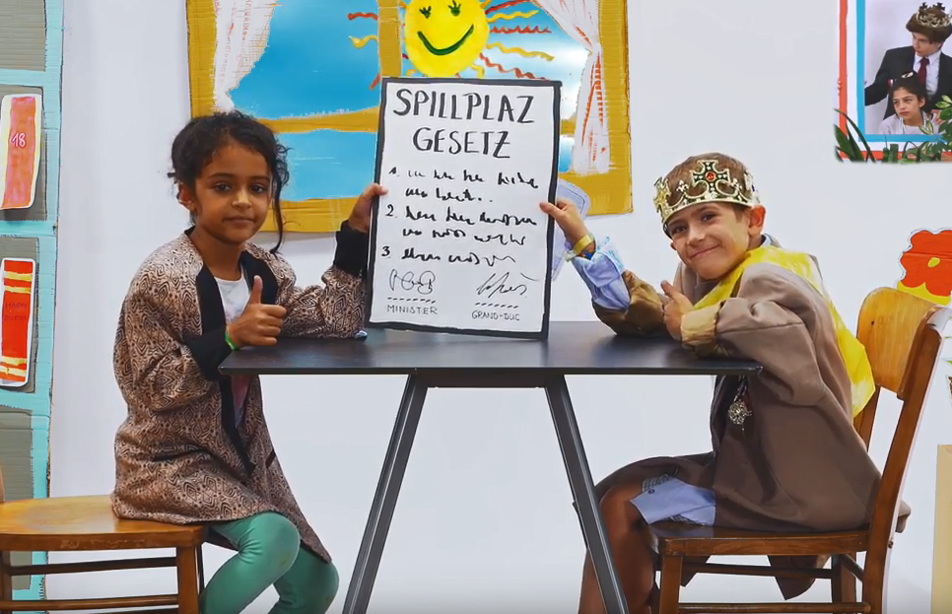 | ___________________________________  ___________________________________  ___________________________________  ___________________________________  ___________________________________  ___________________________________

Nun kann das Gesetz in Kraft treten, d.h. der Bau der Spielplätze kann beginnen!

